JAVA OVERVIEW:

1. What is Java?

* Java is an object-oriented and class-based programming language.
* Java very popular due to its versatility and simplicity to learn (Figure 1).
* Java is the language we will be using to code in FTC.



Figure 1, A Chart Showing Java’s Relative Popularity.

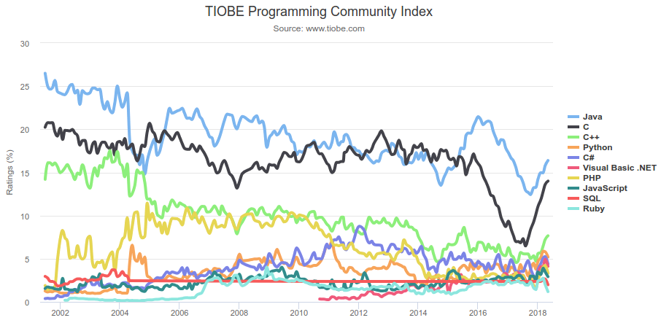

1. The Structure of a Java Program

* A Java project can be broken down into a tree of five items (Figure 2).
  1. Project
  2. Packages
  3. Classes
  4. Voids/Functions
  5. Majority of Code
* While this might not always be accurate, it is a good way for a beginner to see things.
* Packages are collections of classes.
* Classes are compiled Java files.
* For example, in FTC, we will have a project for the robot, packages for collections of systems, classes/files for each subsystem, functions for subsystem tasks, and the code inside will dictate the tasks.

Figure 2, A Flow Chart Showing how Java projects are organized.

1. Recap

* Java is object-oriented and class-based.
* Java Projects can be broken down into a tree.
* Java Classes are compiled Java files.